Why Prompt Engineering Fails for AI Agents - and How to Implement Context Engineering in LangGraph
A complete guide to context engineering: the concept, the 5 levers, and a working 5-node LangGraph pipeline you can run today.

I've built three enterprise RAG pipelines in the last 18 months. Two in banking, one in insurance. All three had the same problem the first time around.
Not with the model. Not with the retrieval. With the context window - specifically, with the assumption that prompt engineering was the right tool for controlling what the model sees.
It isn't. For simple single-turn chatbots, prompt engineering works fine. For AI agents - systems that retrieve documents, call tools, maintain conversation history, and pass state across multiple steps - prompt engineering optimises roughly 5% of what determines the output. The other 95% is what this article is about.
That 95% has a name: context engineering. And by the end of this guide, you'll understand the concept and have a working LangGraph implementation of it.

What This Article Covers
- Why prompt engineering breaks down in production AI agents
- What context engineering is - and the 5 levers it gives you
- A 5-node LangGraph pipeline that implements each lever in code
- A working GitHub repo you can clone and run today

Stack: Python 3.11 · LangGraph 0.2+ · LangChain · OpenAI GPT-4o · MongoDB Atlas
GitHub: https://github.com/anirudhyadav-ai-a/lg-context-pipeline

Part 1: The Problem With Prompt Engineering for Agents
Prompt engineering treats the LLM like a search engine. Craft the right query, get a good result. The craft is in the wording. This model made sense in 2022 when most LLM interactions were single-turn. It breaks the moment you move to agents.
Here is what an LLM actually sees when it runs inside a production agent:

- The system prompt you wrote - typically 200–400 tokens
- Tool definitions - every tool the agent can call, with full descriptions (~500 tokens)
- Conversation history - every prior turn in the current session (~2,000+ tokens)
- Retrieved documents - chunks from your RAG pipeline (~5,000–8,000 tokens)
- Tool call outputs - results from previous tool executions (~1,000 tokens)
- User input - the actual message (~50 tokens)

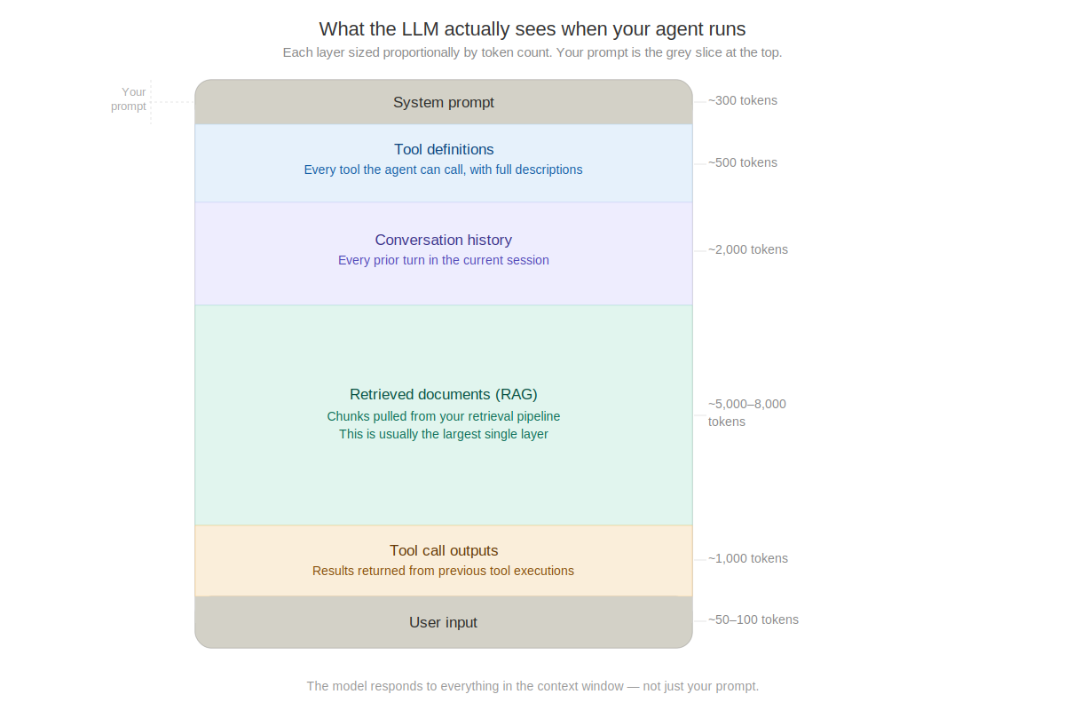
What the LLM actually sees. The system prompt is the small grey slice at the top. Your prompt is one voice in a very crowded room.

Your carefully crafted system prompt might be 300 tokens. The rest of that context window might be 15,000. The model is not responding to your prompt. It is responding to everything.
When your agent gives a bad answer, the instinct is to rewrite the prompt. Nine times out of ten, the problem is elsewhere: the wrong documents were retrieved, the conversation history is carrying stale assumptions, the tool outputs are dumped in as raw JSON, or the state between steps is incomplete.
Tweaking the prompt when the context is broken is like adjusting the seasoning on food that went bad before it reached the kitchen.

Part 2: What Context Engineering Is
Context engineering is the discipline of designing what goes into the model's context window - and in what form, at what time, in what order.
It treats the context window as the primary architecture decision, not the prompt. The questions shift:

Prompt engineering asks | Context engineering asks
How should I phrase this instruction? | What does the model need to know to do this well?
Should I use bullet points or prose? | What should I retrieve, and when?
How specific should I be? | What conversation history is relevant vs noise?
What examples should I include? | How should tool outputs be structured?
How do I handle edge cases in the prompt? | What state needs to persist across steps?

The mental model shifts from what do I say to the model to what information environment does the model need to operate in.

The 5 Levers of Context Engineering
Context engineering gives you five specific controls over the context window. In the next section, each one maps directly to a node in the LangGraph pipeline.

1. Retrieval quality - What documents land in the context window is determined by your retrieval pipeline - chunk size, embedding model, metadata filters, relevance threshold. A bad retrieval strategy fills the context with irrelevant material. No prompt fix compensates for that.
2. Context window structure - Order matters. Models attend more strongly to the beginning and end of their context. Critical information placed in the middle of a 16,000-token window underperforms - even if it's there.
3. History management - Conversation history compounds turn by turn. After ten turns, the model carries everything - including wrong assumptions from turn two. Explicit trimming and summarisation is a core engineering decision.
4. Tool output formatting - Raw API responses dumped into the context are noise. A structured, trimmed, clearly labelled tool output is signal. How you format tool outputs before they reach the next model call determines whether the model can use them.
5. State passing between steps - In a multi-step agent pipeline, each node receives a state object and produces a new one. What you include, how you structure it, and what you deliberately exclude is the architecture of the system - not a prompt decision.

LLMs are more deterministic than they appear. Given identical context, the same model produces nearly identical outputs. The variance you see in production is almost always variance in context - not the model.

Part 3: Implementing It in LangGraph
Theory without implementation is useless. Here is a 5-node LangGraph pipeline where each node controls exactly one of the five levers above.

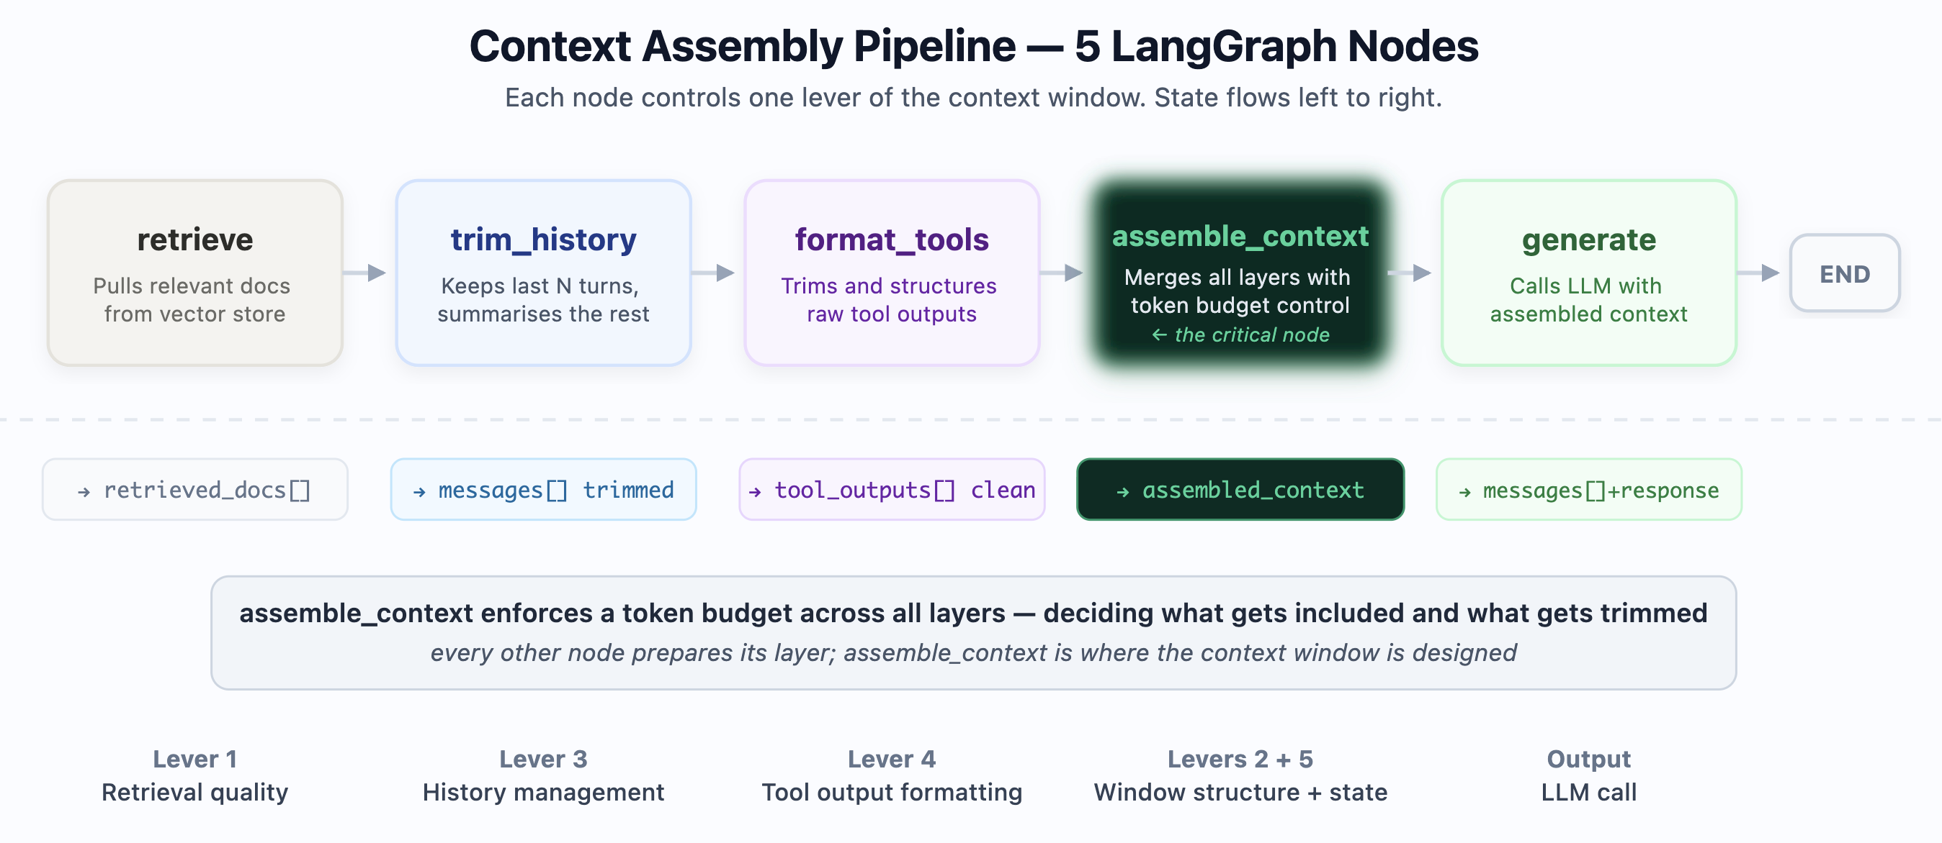
The 5-node context assembly pipeline. Each node controls one lever. State flows left to right before every LLM call.

The pipeline runs before every LLM call. Its job is not to generate anything - it is to assemble the best possible context window given a token budget. Nothing reaches the model without passing through all five nodes.

Step 1 - Define the State
LangGraph's state object flows through every node. Every node reads from it and writes only the keys it owns.
from typing import TypedDict, Annotated, List
from langchain_core.messages import BaseMessage
from langgraph.graph.message import add_messages

class AgentState(TypedDict):
messages: Annotated[list[BaseMessage], add_messages]
query: str
retrieved_docs: List[dict]
tool_outputs: List[dict]
assembled_context: str
token_counts: dict

Step 2 - retrieve (Lever 1: Retrieval Quality)
Controls which documents enter the context window. The 0.75 relevance threshold is the single most important tuning parameter in this node.
from langchain_mongodb import MongoDBAtlasVectorSearch
from langchain_openai import OpenAIEmbeddings

def retrieve_node(state: AgentState) -> dict:
vector_store = MongoDBAtlasVectorSearch.from_connection_string(
connection_string=os.environ['MONGODB_URI'],
namespace='mydb.documents',
embedding=OpenAIEmbeddings(),
)
results = vector_store.similarity_search_with_score(
query=state['query'], k=8,
pre_filter={'status': {'$eq': 'active'}},
)
return {
'retrieved_docs': [
{'content': doc.page_content, 'source': doc.metadata.get('source'),
'score': float(score), 'tokens': estimate_tokens(doc.page_content)}
for doc, score in results if float(score) > 0.75
]
}

Step 3 - trim_history (Lever 3: History Management)
Keeps the last 6 turns verbatim and summarises everything older into a single line. Uses gpt-4o-mini for the summary - it runs on every turn and cost matters at scale.

def trim_history_node(state: AgentState) -> dict:
messages = state['messages']
if len(messages) <= 6:
return {'messages': messages}
recent, older = messages[-6:], messages[:-6]
llm = ChatOpenAI(model='gpt-4o-mini', temperature=0)
older_text = '\n'.join(
f"{'User' if isinstance(m, HumanMessage) else 'AI'}: {m.content}"
for m in older
)
summary = llm.invoke(
f'Summarise in 2 sentences, preserving key facts:\n{older_text}'
).content
return {'messages': [AIMessage(content=f'[Summary: {summary}]'), *recent]}

Step 4 - format_tools (Lever 4: Tool Output Formatting)
Trims raw tool outputs to 900 characters at a word boundary and adds structure. Raw API responses truncated at a character boundary get replaced with clean, labelled text the model can parse.

def format_tool_outputs_node(state: AgentState) -> dict:
formatted = []
for output in state['tool_outputs']:
content = str(output.get('content', ''))
if len(content) > 900:
cut = content.rfind(' ', 0, 900) # truncate at word boundary
content = content[:cut] + '... [truncated]'
formatted.append({
'tool': output['tool_name'],
'result': content,
'tokens': estimate_tokens(content),
})
return {'tool_outputs': formatted}

Step 5 - assemble_context (Levers 2 + 5: Window Structure + State)
The most important node. Takes every prepared layer and merges them into the final context string with a strict token budget. This is where the context window is designed.

TOKEN_BUDGET = 10_000

def assemble_context_node(state: AgentState) -> dict:
parts, used = [], 0

# Layer 1: System context - always first
system = 'You are a precise AI assistant. Answer only from the provided context.'
parts.append(('SYSTEM', system))
used += estimate_tokens(system)
used += state['token_counts'].get('tool_definitions', 400)

# Layer 2: Retrieved documents - sorted by score, budget enforced
doc_budget = TOKEN_BUDGET - used - 1500
doc_parts = []
for doc in sorted(state['retrieved_docs'], key=lambda d: d['score'], reverse=True):
if used + doc['tokens'] < doc_budget:
doc_parts.append(f"[{doc['source']} | {doc['score']:.2f}]\n{doc['content']}")
used += doc['tokens']
if doc_parts:
parts.append(('RETRIEVED DOCUMENTS', '\n\n'.join(doc_parts)))

# Layer 3: Tool outputs - if budget allows
for tool in state['tool_outputs']:
if used + tool['tokens'] < TOKEN_BUDGET - 500:
parts.append((f"TOOL ({tool['tool']})", tool['result']))
used += tool['tokens']

sep = '\n\n' + '='*40 + '\n\n'
assembled = sep.join(f'### {label}\n{content}' for label, content in parts)
return {'assembled_context': assembled, 'token_counts': {**state['token_counts'], 'total': used}}

Step 6 - generate and graph assembly
The generate node is intentionally simple - all the intelligence is upstream.

def generate_node(state: AgentState) -> dict:
llm = ChatOpenAI(model='gpt-4o', temperature=0)
msgs = [{'role': 'system', 'content': state['assembled_context']},
*[{'role': 'user' if isinstance(m, HumanMessage) else 'assistant',
'content': m.content} for m in state['messages']]]
return {'messages': [AIMessage(content=llm.invoke(msgs).content)]}

# --- Build the graph ---
from langgraph.graph import StateGraph, END

graph = StateGraph(AgentState)
graph.add_node('retrieve', retrieve_node)
graph.add_node('trim_history', trim_history_node)
graph.add_node('format_tools', format_tool_outputs_node)
graph.add_node('assemble_context', assemble_context_node)
graph.add_node('generate', generate_node)
graph.set_entry_point('retrieve')
graph.add_edge('retrieve', 'trim_history')
graph.add_edge('trim_history', 'format_tools')
graph.add_edge('format_tools', 'assemble_context')
graph.add_edge('assemble_context', 'generate')
graph.add_edge('generate', END)
pipeline = graph.compile()

Full Working Example

result = pipeline.invoke({
'messages': [],
'query': 'What is our policy on third-party data processors?',
'retrieved_docs': [],
'tool_outputs': [],
'assembled_context': '',
'token_counts': {'tool_definitions': 400},
})

print(result['messages'][-1].content)
# Based on the company policy documents (GDPR Compliance Policy v2.3),
# third-party data processors must sign a Data Processing Agreement...

print(result['token_counts']['total'])
# 4,820 - of a 10,000 token budget

The Impact: Before and After
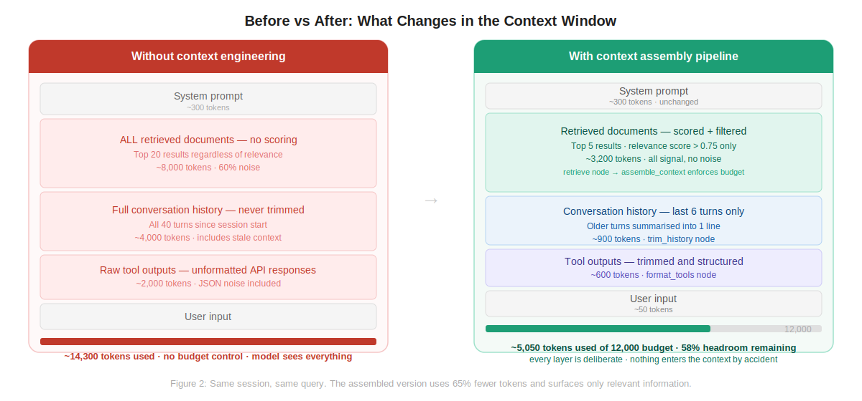
Figure 3: Same session, same query. The assembled version uses 65% fewer tokens and surfaces only relevant information. Every layer is deliberate.

What Can Go Wrong
Error | Cause | Fix
retrieved_docs is empty | Threshold 0.75 too high | Lower RETRIEVAL_THRESHOLD to 0.60 and re-test
Context still oversized | TOKEN_BUDGET set too high for your model | Match budget to your model's effective attention range
History summary loses key facts | gpt-4o-mini truncating complex sessions | Increase MAX_HISTORY_TURNS before triggering summary
Tool output cuts mid-sentence | Character limit not at word boundary | Already handled with rfind(' ') - verify MAX_TOOL_OUTPUT_CHARS
Pipeline slow on every turn | Reassembling context even when inputs unchanged | Cache a hash of inputs - skip reassembly if nothing changed

Summary
Prompt engineering optimises the instruction. Context engineering designs the information environment.
For production AI agents - systems with retrieval, tools, multi-turn history, and multi-step reasoning - context engineering is the discipline that determines whether the system works reliably. The five levers are retrieval quality, window structure, history management, tool output formatting, and state passing between steps.
The 5-node LangGraph pipeline implements each lever explicitly. Nothing enters the context window by accident.

The one thing to remember: your model is not responding to your prompt. It is responding to everything in its context window. Engineer that, and the outputs take care of themselves.

Full code and README at https://github.com/anirudhyadav-ai-a/lg-context-pipeline

